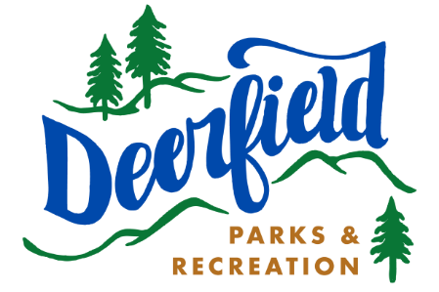

Staff in Training Parent Consent Form

I the undersigned give consent and permission for my child_________________________ DOB__________ to participate in the Deerfield Parks and Recreation Departments Summer Camp Staff in Training Program.
I understand that this is a voluntary position designed to help my child develop skills and training.
As part of the staff in training program I understand that my child will never be directly or solely responsible for children in the camp, but rather will assist Parks and Recreation staff in camp activities and routines.
I also understand that at times my child will be transported by Parks and Recreation staff in the Departments passenger van as well as buses from Dail Transportation.

PARENT/GUARDIAN SECTION
Last Name: ___________________________ First: __________________________________________
Mailing Address: __________________________________________________________________________
Parent Phone _______________________ SIT Phone_______________________________________
Parent Email Address ____________________________________________________________________
SIT Email Address _____________________________________________________________________
Emergency Contact _____________________________ Phone___________________________________
Medical Concerns: _________________________________________________________________________ _____________________________________________________________________________________________

I/We, the undersigned legal parent/guardian of minor (s) mentioned above, give permission for any medical emergency treatment said minor might need during Deerfield Parks and Recreation activity registered for above. Furthermore, I will not hold the Town of Deerfield, Deerfield Parks and Recreation, its staff, Volunteers, or agents responsible for any accidents or injuries occurred during said minor’s participation. I / we agree that said minor listed above is in proper physical and mental condition to allow him/her to participate and that I/We assume the risk of participation. I/We the parent(s)/Legal guardian(s), the undersigned have read this release and understand all its terms. I/We execute it voluntarily and with the full knowledge of its significance. I/We have executed this release on this date indicated next to my/our(s) name(s)

Signature________________________ Date___________________

